USER MANUAL:

**MARKERS ALONG WELL LOG PLOT – A PETREL PLUGIN**

TEAM:

**JUXTAPOSE**

On executing the program the Intersection Window is displayed. A well has already been predefined for the purposes of this demonstration. Its trajectory is color-coded according to the well-log. The Red, Green, and Blue lines represent the X, Y and Z axes, respectively. An isometric projection for a 3 dimensional plot on a 2 dimensional surface has been used.

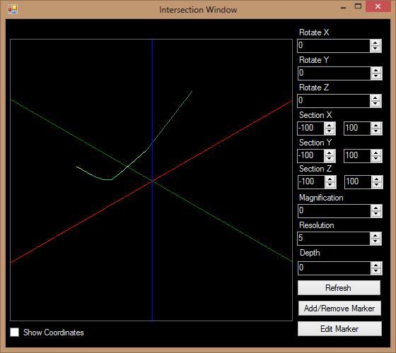

On clicking the Add/Remove Marker button, the Add/Remove Marker dialog box is displayed. Enter the X, Y, Z coordinates of the Marker you wish to create/delete, along with its associated Text.

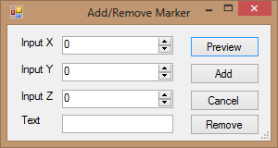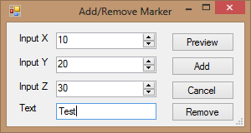

On clicking the Preview button, the temporary marker is visible in Violet, and disappears on clicking the Refresh button.

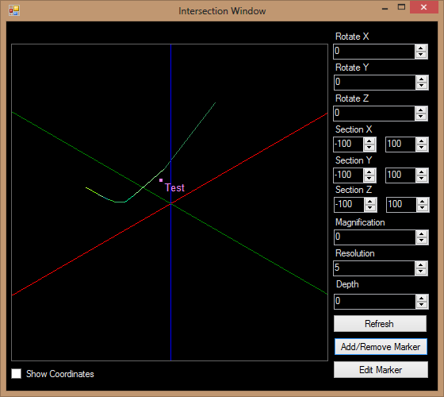

On clicking the Add button, the marker is added in White.

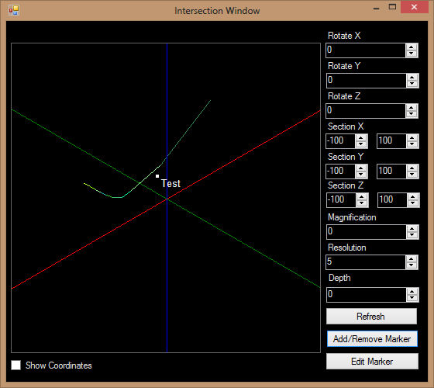

On attempting to add a Marker that already exists, the ‘Uh-oh: That marker already exists’ warning is displayed. However, it is possible to add a Marker at the same position as another yet differing in its Text attribute, or a Marker with the same Text attribute as another yet differing in its position. On attempting to remove a Marker that does not exist, the ‘Uh-oh: That marker does not exist’ warning is displayed.

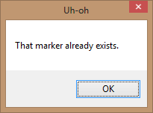 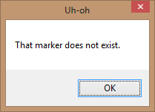

Let us add another Marker for the purposes of this demonstration.

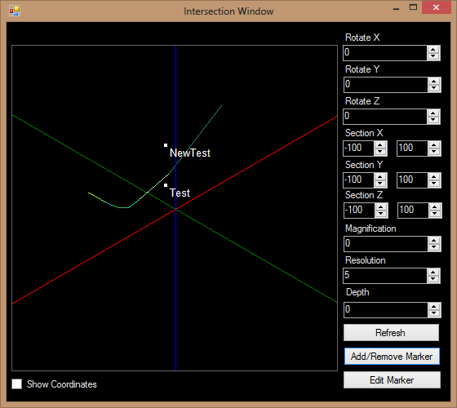

On checking the Show Coordinates check box (and clicking the Refresh button), the coordinates of the Markers are displayed along with their associated Text.

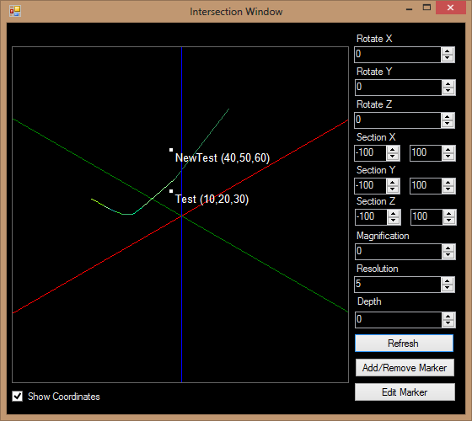

On clicking the Edit Marker button, the Edit Marker dialog box is displayed. The details of the original Marker are entered on the left, and those of the new Marker on the right.

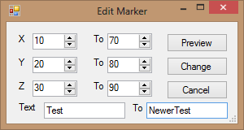

On clicking the Preview button, both the original and the new Markers are temporarily visible in Violet. On clicking the Refresh button, the new Marker disappears and the original Marker is restored.

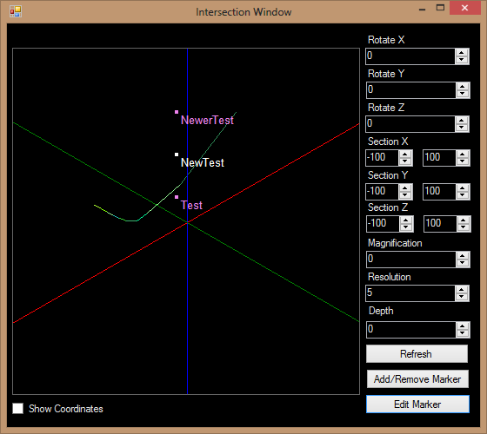

On clicking the Change button, the change is made, and only the new Marker is visible in White.

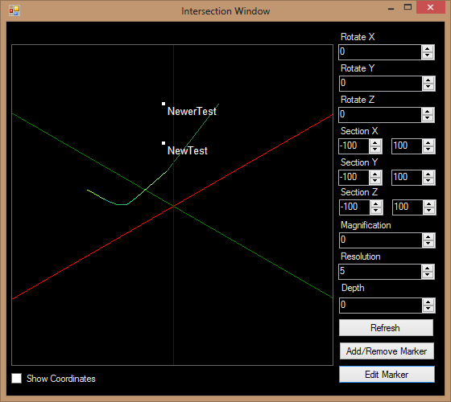

The Rotate X, Rotate Y and Rotate Z numeric up-down buttons can be used to rotate the plot about the X, Y and Z axes, respectively by the angles measured in degrees. They each have a range of -180 to 180. The default value is 0.

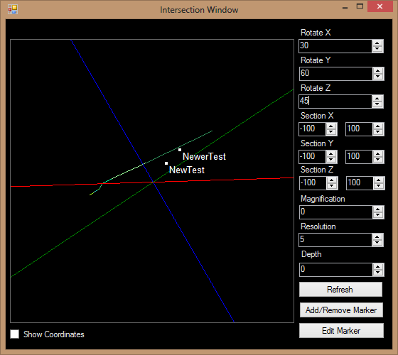

The Magnification numeric up-down button can be used to magnify the plot. It has a range of 0 to 100. The default value is 0.

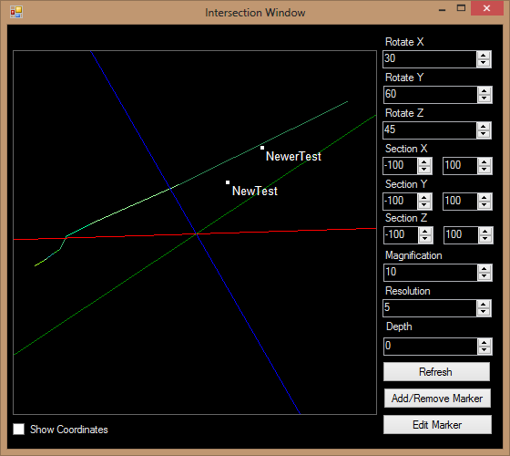

The Resolution numeric up-down button can be used to increase or decrease the size of points and data on the plot. It has a range of 2 to 50. The default value is 5.

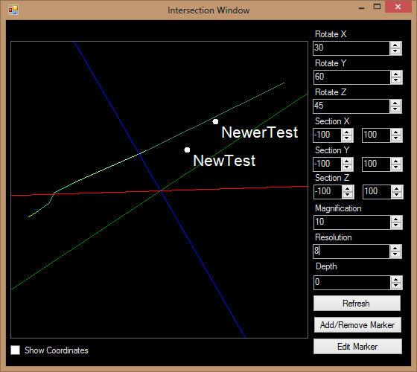

Let us add another marker for the purpose of this demonstration.

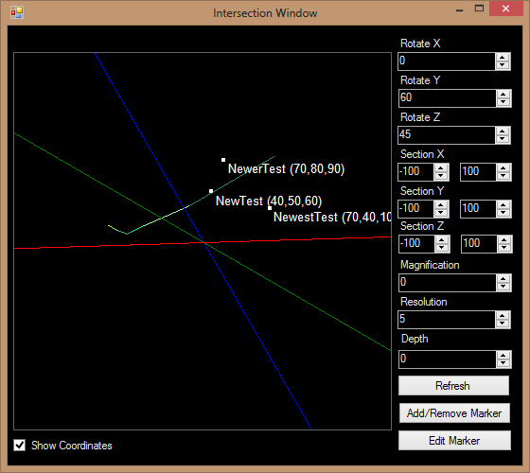

Taking different sections using the Section X, Section Y and Section Z numeric up-down buttons, we are able to hide all Markers that do not fall into that section. This makes concentrating on different parts of the plot easier.

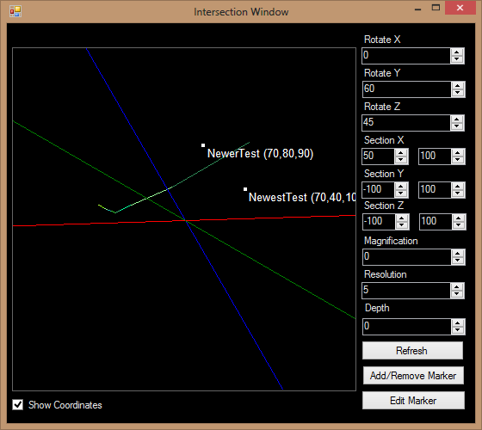

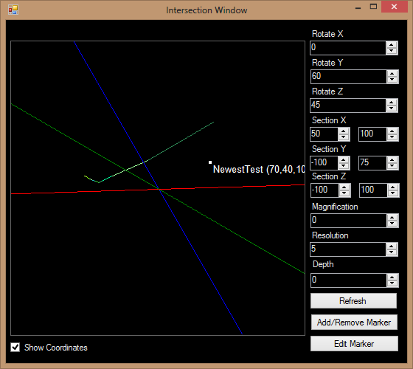

If one Marker is directly in the front of another, the Depth numeric up-down button can be used to reveal only those Markers falling behind the reference point by a certain amount. It has a range of 0 to 200. The default value is 0.

